Enhancement One: Software Design and Engineering

Tuyet Tran

Prof. Joseph Conlan

Southern New Hampshire University

November 16, 2024

1. This artifact demonstrates machine learning using the MNIST dataset, which is designed to train systems to recognize handwritten digits. In July 2024, I modified the program to explore how varying the number of epochs (the number of times the data passes through the training algorithm) impacts the model's performance on the dataset.

2. The handwriting recognition artifact appeals to me because I want to deepen my understanding of machine learning. My goal for this project was to enhance it so that users could interact with the trained system and test its capabilities. To achieve this, I connected user input to a database system, which is then linked to the training program. The system provides outputs to a broader database, which I aimed to enable for recognizing not only words but also special characters.

Additionally, I made the artifact more modular and integrated a NoSQL database, specifically MongoDB, to store user inputs. I also added several files to the artifact to ensure smooth database management and reliable operation.

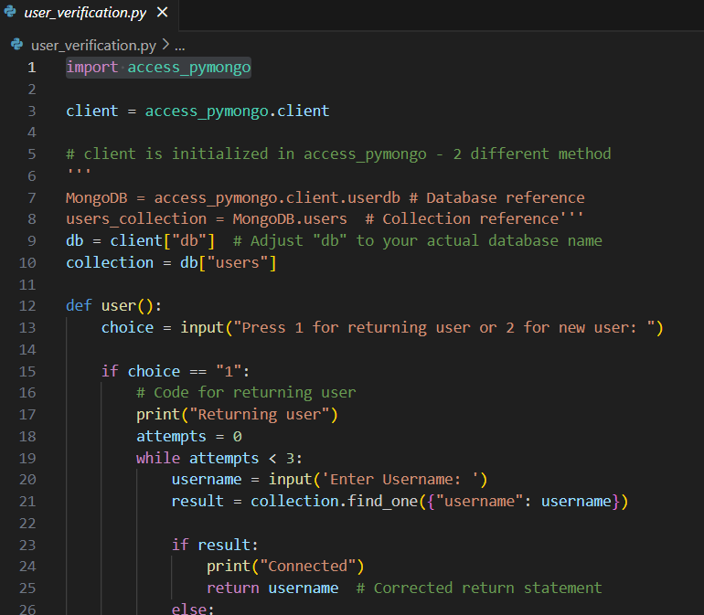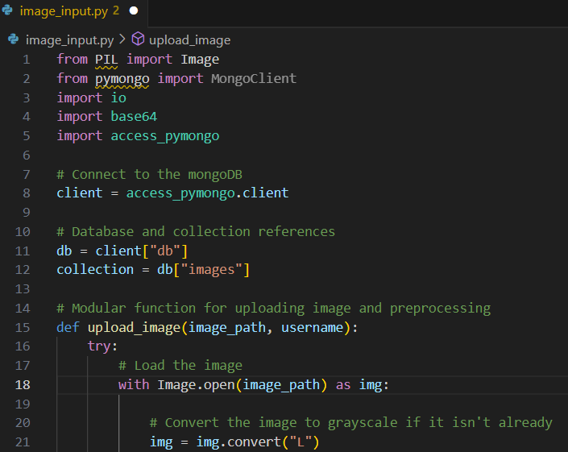

3. The course outcome that I’ve meet is to "develop a security mindset that anticipates adversarial exploits in software architecture and design to expose potential vulnerabilities, mitigate design flaws, and ensure privacy and enhanced security of data and resources." I accomplished this by implementing error handling in areas that require heavy processing, reducing risks, and protecting system stability. Additionally, I learned to create a .env file and configure .gitingore to safeguard sensitive information when submitting code to Git.

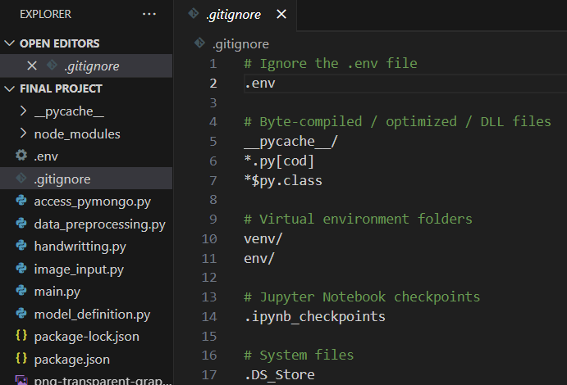

If time permits, I would like to connect my program to a local host site to make it easily accessible and interactive for other users.

4. While modifying the artifact, I learned to set up a MongoDB account in cloud, which provides a certain amount of free cloud storage. Additionally, I learned to work with image inputs using the Pillow library and to store these images in MongoDB. As mentioned earlier, I also learned to protect sensitive information by using a .gitingore file.

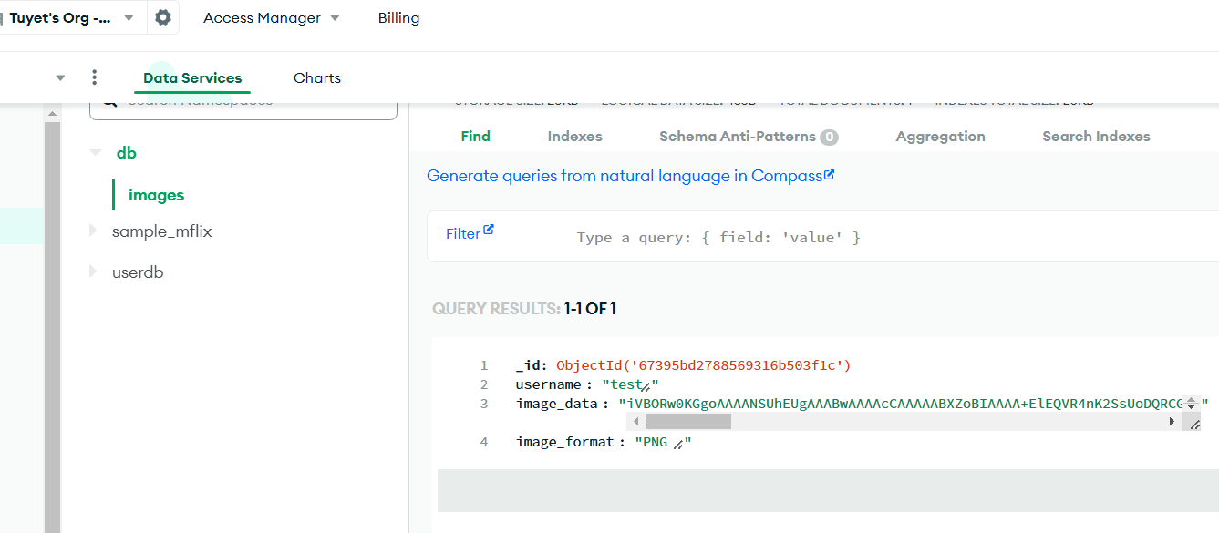

One challenge I faced during this enhancement was with the Keras framework. Unfortunately, I won’t be able to use Keras for the IAM dataset, which will require me to modify many algorithms and the structure of the current artifact. I plan to tackle these changes and challenges upon week.